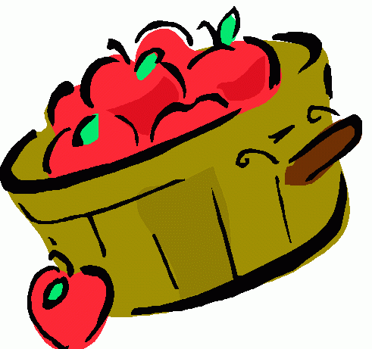 Celebrate Apples!

Please send an apple or two with your child to school on or before September 26th. Please place the apple in a bag with your child’s name.

We will have a week of fun apple activities.

Monday – “Ten Apples Up on Top”
Tuesday - Apple tasting
Wednesday – Johnny Appleseed’s birthday
Thursday – Making applesauce
Friday - Apple Painting

